|  |  |
| --- | --- |
| Description: cee_3line_b_4c_pc_[Converted] | [Description: https://confluence.cornell.edu/download/attachments/10420888/aguaclara_new_logo.jpg](file:///C:\Documents%20and%20Settings\mas352\Desktop\Final%20Designs\DesignSpecs\aguaclara.cee.cornell.edu) |

PRELIMINARY DESIGN FORUI.CityUI.State, UI.Country

UI.Name

UI.Organization

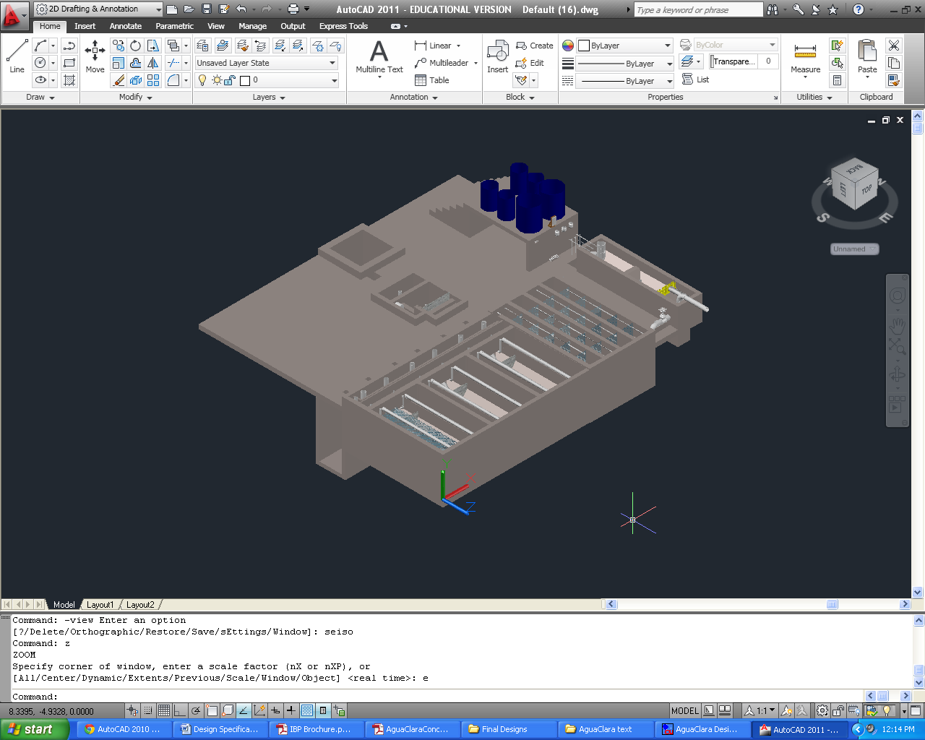

June 4, 2014 at 9:46:57 AM

Copyright © 2010 Cornell University

Table of Contents

[Disclaimer 4](#_Toc326145215)

[Permission and Licensing Information 4](#_Toc326145216)

[Introduction to AguaClara 5](#_Toc326145217)

[The sustainable approach 5](#_Toc326145218)

[The treatment process 6](#_Toc326145219)

[The AguaClara Design Tool 7](#_Toc326145220)

[Design Parameters 8](#_Toc326145221)

[Plant Components 9](#_Toc326145222)

[Entrance tank/preliminary sedimentation 9](#_Toc326145223)

[Linear flow orifice meter (LFOM) 11](#_Toc326145224)

[Chemical dose controller (CDC) 12](#_Toc326145225)

[Chemical storage tanks 16](#_Toc326145226)

[Rapid Mix 18](#_Toc326145227)

[Flocculation 19](#_Toc326145228)

[General Flocculator Design 20](#_Toc326145229)

[Inlet Channel 20](#_Toc326145230)

[Sedimentation Tanks 21](#_Toc326145231)

[Assigning dimensions to the sedimentation tank 22](#_Toc326145232)

[Inlet Manifolds 23](#_Toc326145233)

[Sludge drain 25](#_Toc326145234)

[Tolvas 25](#_Toc326145235)

[Plate settlers 25](#_Toc326145236)

[Launders 26](#_Toc326145237)

[Canal de salida 27](#_Toc326145238)

[Chlorine Disinfection 27](#_Toc326145239)

[Manejo de lodos 29](#_Toc326145240)

[Stacked Rapid Sand Filtration: SRSF 29](#_Toc326145241)

[Materials List 32](#_Toc326145242)

[Entrance Tank 32](#_Toc326145243)

[Flocculation Tank 32](#_Toc326145244)

[Sedimentation Tank 32](#_Toc326145245)

[SRSF 32](#_Toc326145246)

|  |  |
| --- | --- |
| Description: cee_3line_b_4c_pc_[Converted] | Description: https://confluence.cornell.edu/download/attachments/10420888/aguaclara_new_logo.jpg  <http://aguaclara.cee.cornell.edu/>  Dr. Monroe Weber-Shirk, Director |

This preliminary design was requested by UI.Name.FirstUI.Name.Last on behalf of UI.Organization. The design was created on June 4, 2014 at 9:46:57 AM by the AguaClara Design Server at Cornell University. The design is for UI.CityUI.State, UI.Country and has a design flow rate of Q.Plant. The design was created with MathCAD code version SVN.Version.

This design is the result of over 20,000 hours of undergraduate, graduate, and faculty labor. The design incorporates advanced fluid dynamics analysis to ensure easy backwash during filtration. The chemical feed system is based on a series of inventions by the AguaClara team that make it possible to directly set the desired chemical dose and to maintain that dose automatically even as the flow rate through the plant varies..

The economic value of this design is approximately 10,000 USD. This estimate is based on the amount of time that would be required to create this design if an environmental engineering firm used the AguaClara design algorithms, but not the automated design tool, to create this design. The AguaClara team is committed to continue providing this design service because we want to encourage new implementation partners to explore the use of this technology. We also recognize that high design costs would prevent this technology from being available to small communities. However, we do require funding to maintain our design team and to continue to integrate improvements into our designs. We recommend that implementation partners include a design fee for the AguaClara design service in the project budget. The nominal fee (far below its true value) for use of this design service is 1000 USD per L/s of plant capacity. You are welcome to create multiple designs for each facility that you intend to construct to obtain an optimal plant configuration. This fee, which will guarantee continued technical support from the AguaClara team, can be paid to AguaClara by check or [online to Cornell University](http://sites.google.com/site/cuaguaclara/donate). This fee will likely be between 1% and 2% of the overall project cost for a water treatment plant. Thank you for your support.

##### Donate by Check

Make the check to Cornell University

Write AguaClara in the memo field

Mail to: AguaClara, 220 Hollister Hall, Cornell University, Ithaca, NY 14853

# Disclaimer

This document is a DRAFT. It has not been reviewed for official release. It is included with the design files to show what we plan to deliver in the near future.

This design, including the files accompanying this document, is only a draft and must be reviewed and approved by a licensed engineer prior to construction. If you have questions about this design please contact the AguaClara design team at Cornell University at [CUAguaClara@gmail.com](mailto:CUAguaClara@gmail.com).

### Permission and Licensing Information

Copyright © 2010 Cornell University

Authors: The AguaClara team at Cornell University under the supervision of Dr. Monroe Weber-Shirk

This design was created using the open source engineering services of the AguaClara program at Cornell University. It is subject to the [Creative Commons Attribution-ShareAlike 3.0](http://creativecommons.org/licenses/by-sa/3.0/us/legalcode) United States license. If you alter, transform, or build upon this work, you may distribute the resulting work only under the same, similar or a compatible license.

Permission to use this AguaClara Design Tool along with the subsequent AutoCAD renderings and supporting files for design specifications provided by Cornell based on your input parameters (collectively "WORK") and their associated copyrights without a written agreement is hereby granted. Any water treatment plants built using this WORK shall be designed and supervised by a licensed civil engineer.

IN NO EVENT SHALL CCTEC, CORNELL UNIVERSITY, OR THEIR EMPLOYEES BE LIABLE TO ANY PARTY FOR DIRECT, INDIRECT, SPECIAL, INCIDENTAL, OR CONSEQUENTIAL DAMAGES, INCLUDING LOST PROFITS, ARISING OUT OF THE USE OF WORK AND ITS ASSOCIATED COPYRIGHTS, EVEN IF CCTEC OR CORNELL MAY HAVE BEEN ADVISED OF THE POSSIBILITY OF SUCH DAMAGE.

THE WORK PROVIDED HEREIN IS ON AN "AS IS" BASIS, AND CCTEC, CORNELL, AND THEIR EMPLOYEES HAVE NO OBLIGATION TO PROVIDE MAINTENANCE, SUPPORT, UPDATES, ENHANCEMENTS, OR MODIFICATIONS. CCTEC, CORNELL, AND THEIR EMPLOYEES MAKE NO REPRESENTATIONS AND EXTEND NO WARRANTIES OF ANY KIND, EITHER IMPLIED OR EXPRESSED, INCLUDING, BUT NOT LIMITED TO, THE IMPLIED WARRANTIES OF MERCHANTABILITY OR FITNESS FOR A PARTICULAR PURPOSE, OR THAT THE USE OF WORK AND ITS ASSOCIATED COPYRIGHTS WILL NOT INFRINGE ANY PATENT, TRADEMARK OR OTHER RIGHTS.

Users of WORK shall indemnify, hold harmless and defend Cornell, its officers, employees, agents, and the sponsors of the research that let to WORK against any and all claims, suits, losses, damage, costs, fees, and expenses resulting from or arising out of use of WORK. This indemnification shall include, but not be limited to, any product liability. Users of WORK, at their sole cost and expense, shall sufficiently insure their activities in connection with the WORK and obtain, keep in force, and maintain insurance or an equivalent program of self insurance. Cornell shall notify users of WORK in writing of any claim or suit brought against Cornell in respect of which Cornell intends to invoke the provisions of this paragraph. Users of WORK shall keep Cornell informed on a current basis of its defense of any claims under this paragraph.

# Introduction to AguaClara

## The sustainable approach

AguaClara is a program in Civil and Environmental Engineering at Cornell University thatis improving drinking water quality through innovative research, knowledge transfer, open-source engineering, and replicable designof sustainable municipal water treatment systems.

The team is directed by Monroe Weber-Shirk and has worked in Honduras in partnership with a local NGO, AguaPara el Pueblo, and in India with the Tata Foundation and the NGO Pradan. The AguaClara program received the 2011 Intel EnvironmentTech Award in recognition of the success of the program in developing sustainabletechnologies and effective governance models.

Cornell-designed AguaClara municipal watertreatment plants are providing nine Honduran townswith populations between 1,500 and 15,000 with safedrinking water from their taps. The AguaClaraplants in Honduras produce safe drinking water with turnkeydesign, construction, operation, training, and transfercosts of $20 to $30 per person served and incrementaloperating costs of $2-$4 per person per year.The AguaClara technology is uniquely capable ofproducing high quality drinking water from turbid surface waters without using electricity.The facilities use gravity powered chemical dosing, hydraulic flocculation (to form largeaggregates from the contaminants, or flocs), high-rate sedimentation using custom-fabricated platesettlers (to remove the flocs), stacked rapid sandfiltration, and disinfection using liquid chlorine (to kill any residual pathogens that escapedthe previous treatment steps). The designs rely on materials that are sourced in thecommunity and national supply chains. The municipal water treatment plants are designedto be easy and economical to operate.

In India, AguaClara facilities use chemical dosing systems and low flow stacked rapid sand filters to treat groundwater, again, without using electricity.

Extending safe drinking water coverage to resource poor communities requires multipleengineering innovations and a new approach to implementation and governance. Our robust technologies do not require electricity or external power sources. Our governancemodel is based on community ownership, community-based democratic governance, andtechnologies that are specifically designed to be easy to operate and to encourage pride inownership. We build implementation partner capacity and intend to encourage the formationof a network of implementation partners that will share best practices for implementation and long-term operation of community-based water treatment facilities.

This integrated model of technology development for compatibility with a sustainablegovernance model has proven extremely successful. All AguaClara facilities are owned andoperated by their respective communities and all facilities continue to provide safe drinkingwater. This is particularly noteworthy in Honduras where most water treatment plants forlarge cities do not reliably meet drinking water standards. Several towns with AguaClarafacilities are experiencing reverse migration from Tegucigalpa due to their superior water.

Democratic community governance through an elected water board has proven to be veryeffective and the water boards use the water tariffs (that the community has voted toincrease) to fund improvements to their water supply infrastructure. Water boards withAguaClara facilities have invested in reforestation of their watershed, upgrades to theirdistribution system, extensions to their distribution system to add new customers, andongoing maintenance of the water supply infrastructure. Customer willingness to pay forsafe drinking water is significantly higher than their willingness to pay for unsafe riverwater and the difference is greater than the increased operation and maintenance cost ofproviding safe drinking water using AguaClara technologies.

Our goal is to disseminate this technology and our learning regarding sustainablegovernance globally. The AguaClara engineering designs are shared online to facilitatetechnology dissemination and to reduce design costs. National engineering firms (non-profit,private, or governmental) are trained to build the water treatment facilities using locallyavailable materials and community labor. Our partners work with locally-trusted organizations to develop a governance model that is suited to the natural resources, nationalgovernance framework and available social and human capital of a particular community.

We are seeking funding that will support our research and development work to extend therange of community sizes that can be served using the AguaClara technologies. We haveexperience with communities between 1,500 and 15,000 and plan to extend that range inboth directions. We are researching several technologies that have the potential to reducethe construction and operating costs of the water treatment plants and need funding tosupport that effort. There are significant engineering and governance challenges as wedevelop approaches to community based water treatment for communities with fewer than1,500 inhabitants. Extending our design capabilities for treatment facilities that can servelarger cities is easier. The engineering and technical challenges will require developing newfabrication methods, testing prototypes for performance, and coding the new designs fordissemination via our online design tool.

We are also interested in testing models for implementation and governance. Ourexperience suggests that partnerships between the AguaClara team at Cornell,implementation partners, and community governance bodies realize their full potential whenthere is a high level of trust between the organizations and an ongoing technical assistancecircuit rider. The AguaClara technologies are designed to encourage the creation of trustand self-sufficiency by being easy to understand and easy to maintain even in resource poorcommunities. We would benefit from experiences with different types of implementationpartners and with more governance and technical assistance models to learn which approaches are most effective forvarious situations.

The AguaClara program overcomes the major barriers to safe drinking water that werepreviously encountered by small communities. We estimate that well over 100 millionpeople living in Latin America and the Caribbean, Africa, and Asia could benefit from thesetechnologies. The resilient design, innovative fabrication methods based on locally availablematerials, the automated design tool, and community based governance hold the prospectof improving the quality of life in thousands of communities in the coming years.

# Design Overview

## The treatment processfor groundwater

AguaClara plants treat turbidity, pathogens, and natural organic matter using rapid sand filtration and disinfection processes. Treatment begins with removal of large debris and preliminary sedimentation of large particles. Then coagulant, which promotes the aggregation of suspended particles,is added to the raw water through a semi-automatic chemical dosing system.The coagulant is mixed with water in a rapid-mix pipe, which delivers macro-scale mixing through minor losses due to pipe configuration, and micro-scale mixing through an orifice plate. The rapid-mix pipe carries the mix of water and chemical coagulant to the filtration system.

AguaClara’s one-of-a-kind low flow stacked rapid sand filter (LFSRSF) is composed of six sand layers arranged one on top of the other. The main input pipelines are connected to a series of slotted pipes, which spread the settled water throughout the plan view area of each layer. As water travels through the sand layers, dirt and organic matter are captured in the pore space of the sand, and the filtered water is collected by outlet pipes (that also use slots) arranged in the sand layers. A siphon system and pipe stubs that vary the water outlet elevations enable the filter to self-backwash, minimizing demand on the operator, and (unlike conventional rapid sand filters) removing the need for electricity, pumps or electronic systems.

The final step in the AguaClarawater treatment process is disinfection. The semi-automatic chemical doser delivers chlorine to the filtered water. The chlorinated water is stored in a distribution tank to allow for sufficient contact time with the chemical, ensuring the water is fully disinfected. After disinfection, the treated water is ready for distribution to households. Water treated by the AguaClara system is consistently below 5 nephelometric turbidity units (NTU), and frequently meets the US standard for maximum turbidity, 0.3 NTU.

## The AguaClara Design Tool

In the AguaClara Design Tool (ADT), the basic design parameters requested (e.g. flow rate, wall thickness, number of sedimentation tanks desired, the dimensions of purchased lamella material, etc.) are used as variables in a series of hydraulic and geometric algorithms that define the dimensions of the plant reactors and their accessories. The design algorithms in the ADT are based on fundamental physics, and thus are scalable over a wide flow range. Algorithms have been revised and constrained based on lab research and feedback from the field to ensure both efficient material usage and ease of operation. The software output based on these parametric algorithms is a three-dimensional drawing in AutoCAD of each reactor that is to be given to the designer. The designer completes the design based on the ADT output by adding the final treatment components, the plant building, and distribution system, and then the designer must perform a full structural analysis of the plant. This document provides a summary of AguaClara processes with regard to the design of closed facilities. Consequently, all calculated values (e.g.lengths of plant reactors, distances between the centers of the orifices, etc.) are specific to this plant design, and do not necessarily apply to other AguaClara plants.

## PlantOverviewfor UI.CITY

Included is the design for a plant for UI.Cityhaving a maximum flow rate of Q.PlantL/s. The design was created assuming specific input parameters, shown in Table1 below. The software uses these parameters together with the requested flow rate as variables in a series of hydraulic and geometric calculations that define the dimensions of the various plant components. The goal of the plant with respect to water quality is to reduce theturbidity to it meet international water quality standards (less than 5 NTU), maintain the color within norms, disinfect the water with chlorine, and maintain a residual chlorine concentration throughout distribution between 0.3 and 1.0 mg/L. The plant treats water without using electricity, utilizing flow control, coagulant dosing, rapid mix,rapid sand filtration, and chlorination.

|  |  |
| --- | --- |
| **Maximum flow rate** | Q.Plant |
| **Maximum Chlorine Dose** | C.ChlorineDoseMax |
| **Maximum Coagulant Dose** | C.CoagDoseMax |
| **Number of LFSRFs** | N.LFSRSF |
| **Plant Construction Specifications** | |
| ?????? |  |
|  |  |
|  |  |

Table 1. General Plant Assumptions

The treatment processeshave been designed according to the maximum flow rate, Q.Plant L/s. While the resulting dimensions and layout have been cost optimized wherever possible, the user may choose to change some values if need be.

# Plant Components

## EntranceTank

## Linear flow orifice meter (LFOM)

The linear flow orifice meter, or LFOM, is the riser pipe found in the the entrance tank. Water exits the entrance tank through the orifices in the LFOM, is dosed with coagulant, undergoes rapid mix, and then enters the filtration system. The diameter of the pipe is set such that cross-sectional area of the pipe required is Pi.LfomSafety times the minimum area required to carry the average velocity of water in the pipe, giving aND.RMPipe in nominal diameter pipe. The additional area ensures that water free falls into the rapid mix pipe so the flow in the pipe is hydraulically disconnected from the flow through the entrance tank. The orifice pattern in the LFOM is designed to approximate the shape of a sutro weir, which forces a linear relationship between the flow rate over the weir and the head loss over the weir. The maximum head loss over the weir is set to be HL.Flowmeasure, since the sutro weir approximation is not valid at higher head losses. Assuming a B.LfomRows spacing between the rows of orifices, the theoretical flow area required in the top B.LfomRows of the LFOM can be calculated, and the orifice size is set to be no larger than that to ensure at least one orifice can be placed in the top row. This design requires D.LfomOrifices diameter orifices.

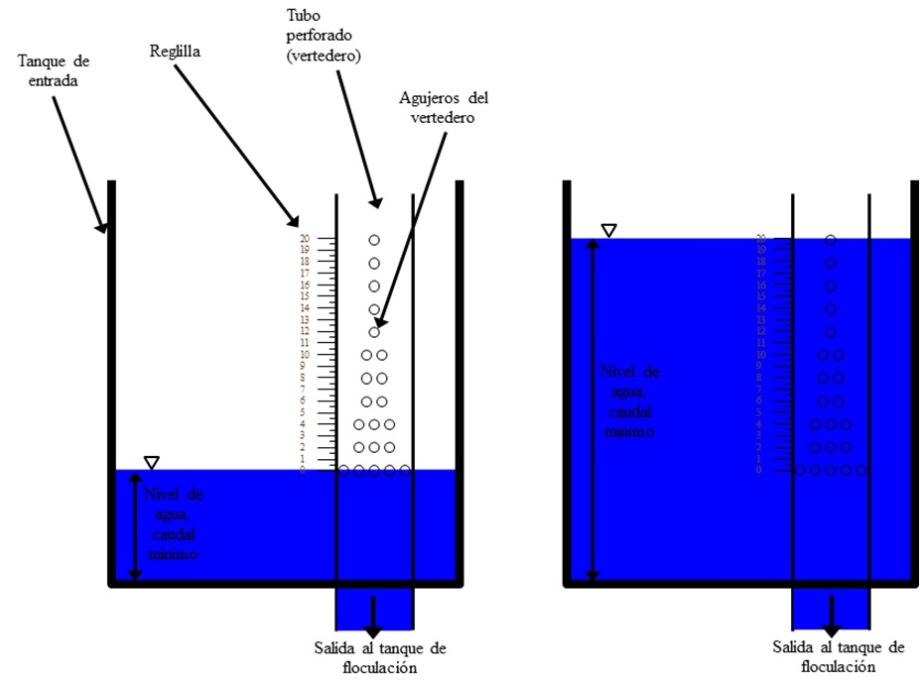

**Figure 1**: AguaClara Linear Flow Orifice Meter

The number of orifices in each row is calculated by minimizing the mean square error as compared to perfectly linearized flow. Table 2 gives the orifice pattern for this specific design.

|  |  |
| --- | --- |
| **Row Height (m)** | **Number of Orifices** |
| H.LfomOrifice1 | N.LfomOrifices1 |
| H.LfomOrifice2 | N.LfomOrifices2 |
| H.LfomOrifice3 | N.LfomOrifices3 |
| H.LfomOrifice4 | N.LfomOrifices4 |
| H.LfomOrifice5 | N.LfomOrifices5 |
| H.LfomOrifice6 | N.LfomOrifices6 |
| H.LfomOrifice7 | N.LfomOrifices7 |
| H.LfomOrifice8 | N.LfomOrifices8 |
| H.LfomOrifice9 | N.LfomOrifices9 |
| H.LfomOrifice10  Table 2.The orifice pattern in the LFOM for UI.City. The row height is measured from the bottom of the orifices in the first row. | N.LfomOrifices10 |

## Chemical dose controller (CDC)

The coagulation and disinfection processes require precise dosage of coagulant solution to the influent of the plant (raw water) and ​​solution of calcium hypochlorite to the plant effluent (filtered water). The CDC is hydraulically connected to the entrance tank, enabling the control system to automatically adjust the flow of chemical solution through the plant to maintain the desired dose even at varying flow rates. The coagulant serves to reduce the forces that keep colloidal particles in suspension and thus allow flocculation. The chlorine from calcium hypochlorite eliminates the remaining microorganisms after filtration that protects against contamination in the distribution network. To carry out this process without pumps, the AguaClara plant uses a hydraulic metering system called as the chemical dose controller. The main components of the system are storage drums, stock solution, an elevated platform to raise drums , chemical calibration columns, a float valve that maintains a constant liquid level, the dosing system that provides the required relationship between the pressure drop in the system and the flow of chemicals, and a scale in the inlet tank of the plant.

This system has the capacity of automatically shutting down when there is no flow in the plant and change the flow of chemicals automatically in proportion to the level of water in the inlet tank , which is linearly proportional to the flow rate of the plant due to LFOM. The first provides security against excess chemical pollution and wastage of chemicals in the event of plant shutdown without the need of manually stopping the chemical flow. The second allows an operator to select the dose easily without doing any calculations, and without manipulating the system each time the flow in the plant is changed.

Chemicals are stored in containers placed in an elevated table, from which the coagulant and chlorine flows to the two constant head tanks equipped with float valves. The float valves maintain constant liquid level in the tanks, which provides a constant level which is used to control the flow of each chemical hydraulically. In this way the flow of chemical is independent of the fluid level in the storage containers. The chemical solution leaving the tank respectively flows through a flexible tube of larger diameter, where there is no significant head loss , then to a " manifold" that divides the flow between several straight tubing with a smaller diameter (Figure 2) . The system of small diameter tubing serves as the main element of head loss in the flow path, so that major losses are more critical and minor losses (expansions) are kept minimal. The system is designed so because major losses in a laminar flow regime provide a linear relationship between flow and hydraulic head while the minor losses have a nonlinear relationship with the flow. A collector at the other end of the small diameter tube combines flow again and a large diameter tube leads to the metering device mounted on the tank wall of the plant.

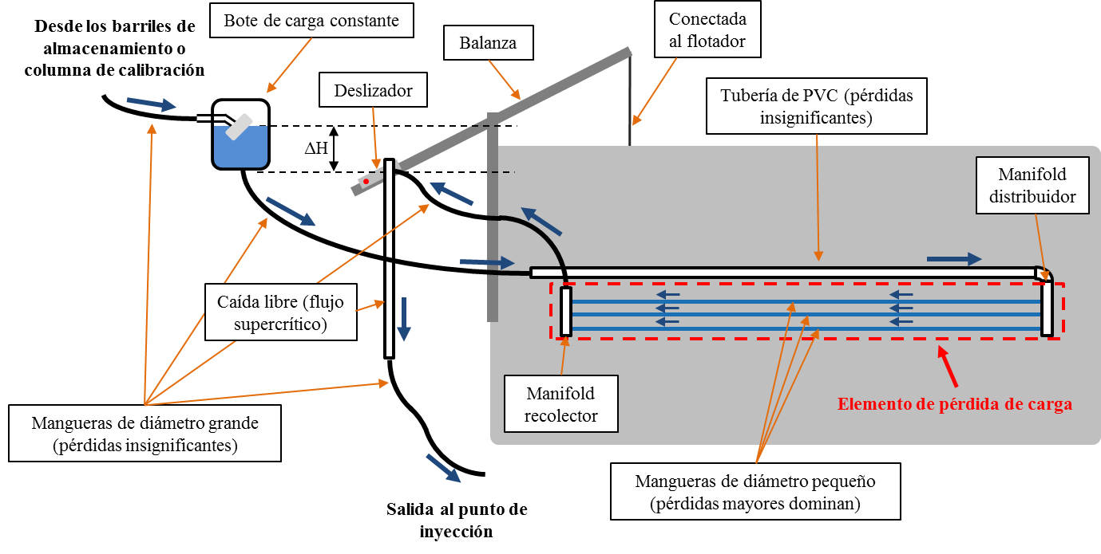

The blue arrows indicate the path of the constant head chemical tank, small diameter pipes, and ending on the slider on the scale. The height of the outlet of the tube in the slider is what controls the chemical flow. Hence, the chemical falls in the PVC pipe and is

injected into the raw water.

**Figure 2**: AguaClara Chemical Dose Controller

The metering device consists of a lever system mounted on the tank wall and a large diameter drop tube (to ensure supercritical flow) that leads the solution to the raw wáter. As pictured in Figure 3, a ND.EtFloat diameter float hangs from the dosing lever arm and sits in the entrance tank. The left side of the lever arm is marked with a dosing scale and has a drop tube attached to a slider. The operator moves the slider along the left side of the arm to set the desired dose. The plant geometry is such that a double lever arm connects the entrance tank float to the chlorine and coagulant stock tanks, thus enabling the operator to control dosing of both chemicals from a single location. At the other end of the scale a float is attached to the inlet tank. When there is no flow through the plant, as shown in Figure 3, the dosing arm is level, and there is no head to drive the flow of chemical. When water is flowing through the plant, as shown in Figure 4, the float rises along with the water level in the tank, dropping the dosing point below the elevation of the fluid level in the constant head tank, and thus providing a driving head for chemical flow.

### 

In no flow mode, the fluid level elevation in the constant head tanks is same as that of the dosing point, meaning there will be no flow of chemical into the plant. Note that the small tubes are not shown in the diagram for clarity

**Figure 3**: Chemical Dose Controller at zero plant flow rate or in “no flow” configuration

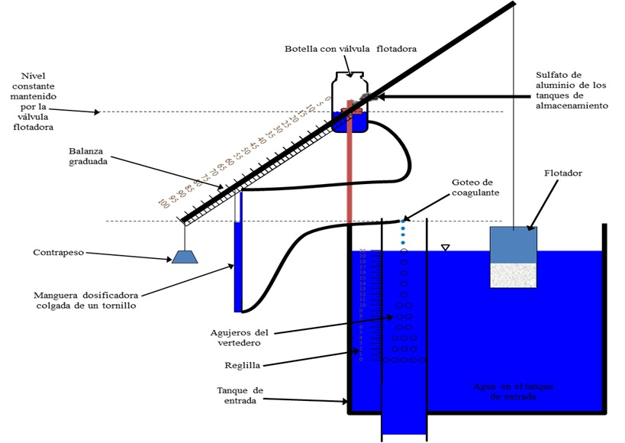

The driving head for the chemical stock solution is given by the elevation difference between the fluid level in the constant head tank and the dosing point. Note that the slider is at the maximum dose point. Note that the small tubes are not shown in the diagram for clarity

**Figure 4**:Chemical Dose Controller in the “Operating” mode

### CDC: DesignSpecifications

Table 5 lists the complete specifications for the dose controllers.

|  |  |  |
| --- | --- | --- |
| **Chemical Dose Controller Specifications** | | |
| ***General parameters*** | | |
| Coagulant Type | EN.Coag | |
| ***Chemical Concentrations*** | | |
|  | *Filter coagulant* | *Chlorine* |
| Maximum Dose | C.CoagDoseMax | C.ChlorineDoseMax |
| Maximum Stock Concentration | C.CoagStock | C.ChlorineStockMax |
| ***Tanks and Floats*** | | |
| ET Float diameter | ND.EtFloat | |
| ET Float height | L.EtFloat | |
|  | *Filter Coagulant* | *Chlorine* |
| Float valve orifice diameter | D.CoagFloatValveOrifice | D.ChlorFloatValveOrifice |
| Stock tank to constant head tank tube diameter | D.CoagTubeStockToCH | D.ChlorTubeStockToCH |
| Large tube diameter (see CDC Design Alg.) | ??????????? | ??????????? |
| Flow Rate from Stock | Q.CoagStock | Q.ChlorineStock |
| ***Lever Arm and Drop Tube*** | | |
| Lever arm length (total) | L.LeverArmTotal | |
| Float Arm Length | L.CdcFloatArm | |
| Scale Arm Length | L.CdcScaleArm | |
| Drop Tube Length | L.DropTube | |
| Drop Tube Diameter | ND.DropTube | |
| ***Dosing Tubes for Flow Control*** | | |
| Minor loss coefficient | K.CdcTube | |
|  | *Filter Coagulant* | *Chlorine* |
| Number of Tubes | N.CdcCoagTubes | N.CdcChlorineTubes |
| Length of Tubes | L.CdcCoagTube | L.CdcChlorineTube |
| Diameter of Tubes | D. CdcCoag | D.CdcChlorine |
| Maximum head loss through small-diameter tubing | HL.CdcCoag | HL.CdcChlorine |

Table .Chemical dose controller design for UI.City.

### CDC: Calibration and Operation

When there is no flow through the plant, as shown in Figure 3, the dosing arm is level, and there is no head to drive the flow of chemical. When water is flowing through the plant, the float rises along with the water level in the tank, dropping the dosing point below the elevation of the fluid level in the constant head tank, and thus providing a driving head for chemical flow. This situation is pictured in Figure 4. To decrease the chemical dose, the operator needs to move the slider to the desired dose marked on the scale of the level arm. With the slider moved further to the right, the dosing point elevation does not decrease as much as the float rises, and so the driving head – and thus the chemical flow – decreases.

Recall that the water height in the entrance tank changes linearly with the flow rate going through the plant due to the LFOM. Similarly, the flow of chemical stock solution is linearly related to the elevation difference between the fluid level in the constant head tanks and the dosing point. The linear relationship between the driving head of the chemical and the chemical flow rate is established by designing the dosing tubes such that the head loss is dominated by major(shear) losses. The lengths of the dosing tubes are limited by the need to have the tubes drape without hitting the floor.

drop tubes

For the doser to function optimally, it is crucial for each component to be installed correctly. To properly calibrate the doser once it has been mounted to the entrance tank, the no flow situation needs to be simulated in the entrance tank (Figure 3) by draining the tank until its water level is just below the bottom of the LFOM’s bottommost row of orifices. Then, with the lever arm perfectly horizontal, adjust the length of the rope attached to the float so that the float sits exactly vertically. With the lever arm in the horizontal position, mount the constant head tank such that its fluid level is at the same elevation as the dosing point. Then, fill the entrance tank until the water height corresponds to the maximum flow rate (where the topmost orifices of the LFOM are just submerged, as in Figure 4). The elevation of the maximum dose point on the scale should have decreased by the maximum allowable head loss for the chemical. Position the slider to an intermediate dose, because this method leaves extreme flow rates less susceptible to calibration errors.)At the intermediate dosing position, measure the flow of chemical through the dosing tube and compare it to the theoretical flow rate, which can be calculated by rearranging Eq 2 as follows:

Eq .

where hf is given by the elevation difference between the dosing point and the fluid level in the constant head tank. If the flow rate is greater than the theoretical, cut the tube and repeat the test until the theoretical value matches the measured value. If the flow rate is less than the theoretical, a longer tube must be obtained and the calibration must begin again from the first step. Once the theoretical and measured values match, the doser is ready for use.

In addition to good calibration, the doser must be periodically cleaned for good performance. Any sediment that may be clogging the valves or fittings must be cleaned out to prevent underdosing. Additionally, air bubbles in the tubes will cause dosing errors. If bubbles are present, remove the tube from the dosing system and force the bubbles out.

### CDC: Design Algorithm

The following sections gives an outline of the methods used to design the CDC, which might be useful when troubleshooting the apparatus.

Recall that the water height in the entrance tank changes linearly with the flow rate going through the plant due to the LFOM. Similarly, the flow of chemical stock solution is linearly related to the elevation difference between the fluid level in the constant head tanks and the dosing point. The linear relationship between the driving head of the chemical and the chemical flow rate is established by designing the dosing tubes such that the head loss is dominated by major(shear) losses. The lengths of the dosing tubes are limited by the need to have the tubes drape without hitting the floor. The tubes must hang freely and have space for a weight to keep the tube as straight as possible, minimizing additional losses that would cause errors in the flow calculation. Moreover, the tubes cannot be too short, or else the number of tubes required to supply the needed flow gets high, and the apparatus gets complicated. To determine the best combination of lengths and numbers of tubes, we need to first determine the possible flow rates available from purchasable tubing diameters. Allowing no more than a ΠLinearCdcError = 10% deviation from the desired linear flow relationship due to minor losses, the flow rate, QAvailable, through each available tube size is calculated as given in Eq 1below.

Eq .

The diameter of the tube is D, the maximum headloss through the dosing system is HLCdc, g is the gravitation constant, and KCdcTube = K.CdcTube is the minor loss coefficient for the tube.

Modifying the Hagen-Poiseuille equation for the length of a tube, given major head loss hf, tube diameter, fluid viscosity ν, and fluid flow rate (Eq 2), the required length LCdcTubeof each tube to obtain the desired head lossat maximum flow may then be calculated for each available flow rate (Eq 4).

Eq .

Eq .

Eq .

When the length of the tube is being calculated, the true viscosity of the fluid is unknown, and so the viscosity of the maximum stock solution is assumed for the case of the coagulant. The viscosity of chlorine is assumed to be that of water since the solution must be sufficiently dilute to produce simple designs.

Once all possible lengths for each diameter have been calculated, the algorithm chooses the longest tube and associated diameter that is smaller than the maximum length to ensure draping. This decision minimizes the number of tubes, keeping the doser as simple as possible. At this point, the number of dosing tubes NCdcTubesassuming the maximum chemical stock concentration CChemStockMax can be calculated as follows in Eq 5:

Eq .

whereQPlant is the maximum plant flow rate, CMaxDose is the maximum allowable dose, and QTube is the flow rate through the design tube.

Finally, the required chemical stock concentration can be specified based on the calculation in Eq 6.

Eq .

In the event that the required tube length is not long enough to reach from the constant head tank to the drop tube, the small-diameter design tube may be linked to a larger diameter tube just long enough to reach the dosing point.

## Chemical storage tanks

There are two to four storage tanks for each chemical on the stock tank platform – two for the main plant coagulant, two for chlorine disinfection, and optionally two for coagulant dosing before filtration, as shown in Figure 6. The stock tanks are set at an elevation of Z.CoagTank to provide enough head to overcome minor losses in the system, ensuring the desired flow rate can be attained. The design of the chemical storage tanks is based on the tank volumes available for purchase through Rotoplast for Latin America, and it is assumed that the stock tank will be refilled no more frequently than once every Ti.StockMin. In order to determine the required volume of a chemical tank, the maximum chemical flow rate, QChemStockMax, must first be determined as follows:

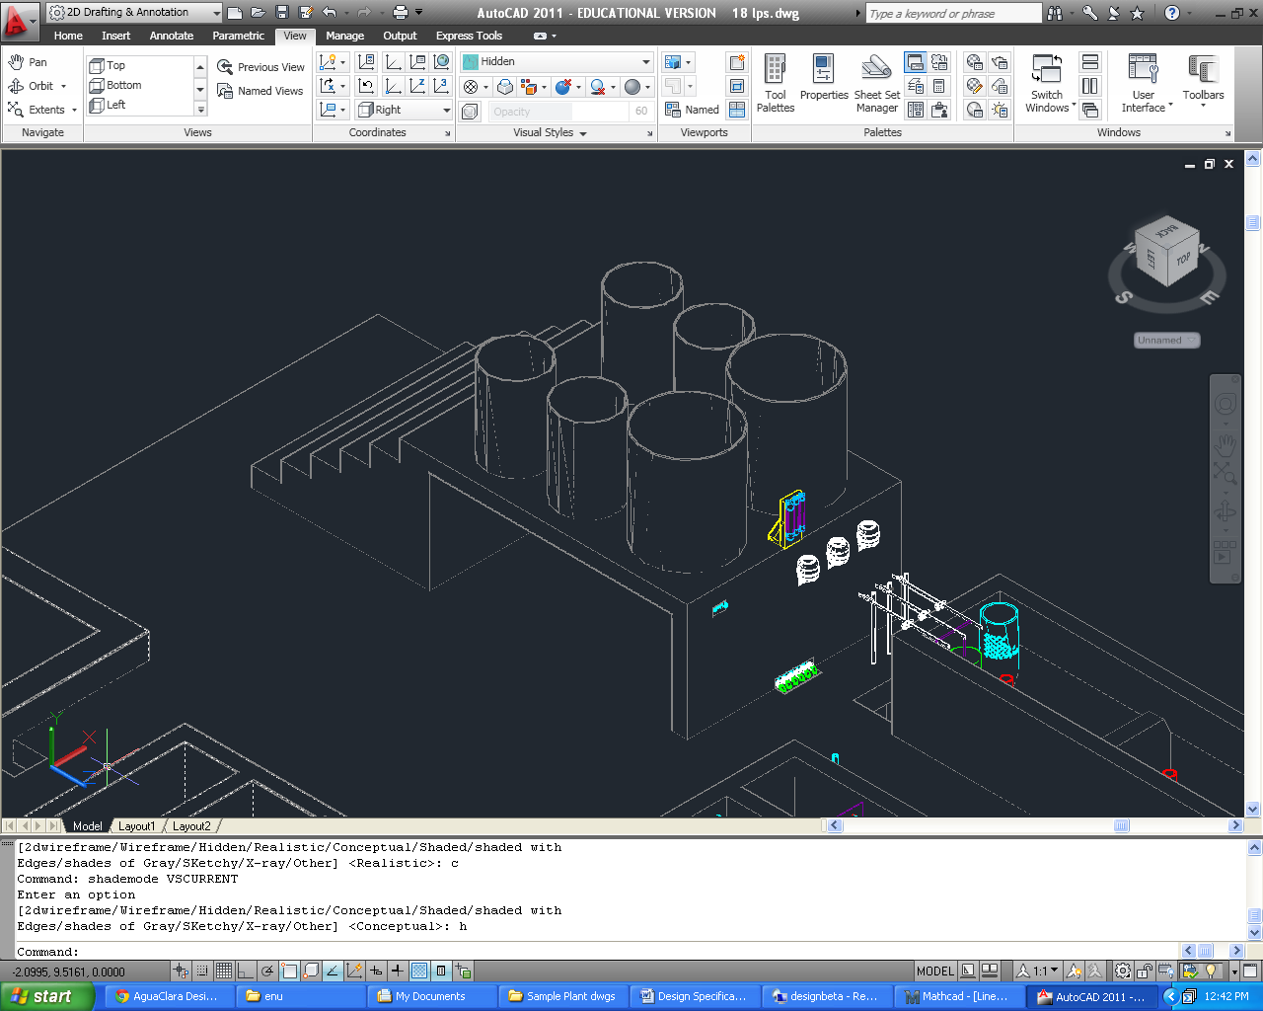

Figure . Chemical stock tanks for an 18 L/s plant.

Eq8

whereCChemDoseMax is the maximum allowable chemical dose, and CChemStockis the stock concentration in the chemical tank. Using the maximum chemical flow rate,the volume of the stock tank, VolChemTank,is computed using the following formula:

Eq9

For plants that require stock tank volumes slightly larger than the nearest available tank volume, the ADT automatically rounds down to the nearest desired volume to make the size as small as possible. Specifications for this particular stock tank design are given in Table6 below.

|  |  |
| --- | --- |
| **Stock TankSpecifications** | |
| Turnover time for the chlorine stock | Ti.ChlorineStock |
| Height of the chemical tanks above the constant head tanks | H.CoagTankAboveHeadTank |
| Dose and drain plumbing size | ND.CoagPiping |
| Coagulant tank volume | Vol.CoagTank |
| Chlorine tank volume | Vol.ChlorineTank |
| Filter coagulant tank volume | Vol.FiCoagTank |
| Height of stock tanks above constant head tanks | H.CoagTankAboveHeadTank |

Table 6.Chemical storage tank design for UI.City.

All of the piping required to administer the dose and drain the stock tanks (Figure 7) uses a nominal diameter of ND.CoagPiping. The piping that connects to the constant head tanks begin at a bulkhead fitting set at an elevation of B.StockOutlet higher than the bottom of the stock tanks to prevent sediment from entering the pipes. The flow is controlled at the top of the stock tank platform using a ball valve, and the plumbing continues down through the platform, and out through the wall facing the entrance tank at the approximate elevation of the constant head tanks. The stock tank drains are connected from the bottom center of the tanks, starting with a male insert, and continuing under the platform and exiting via ball valve at the edge of the main plant drain channel. Figure 8 shows more close up details of the dosing and chemical drain plumbing.

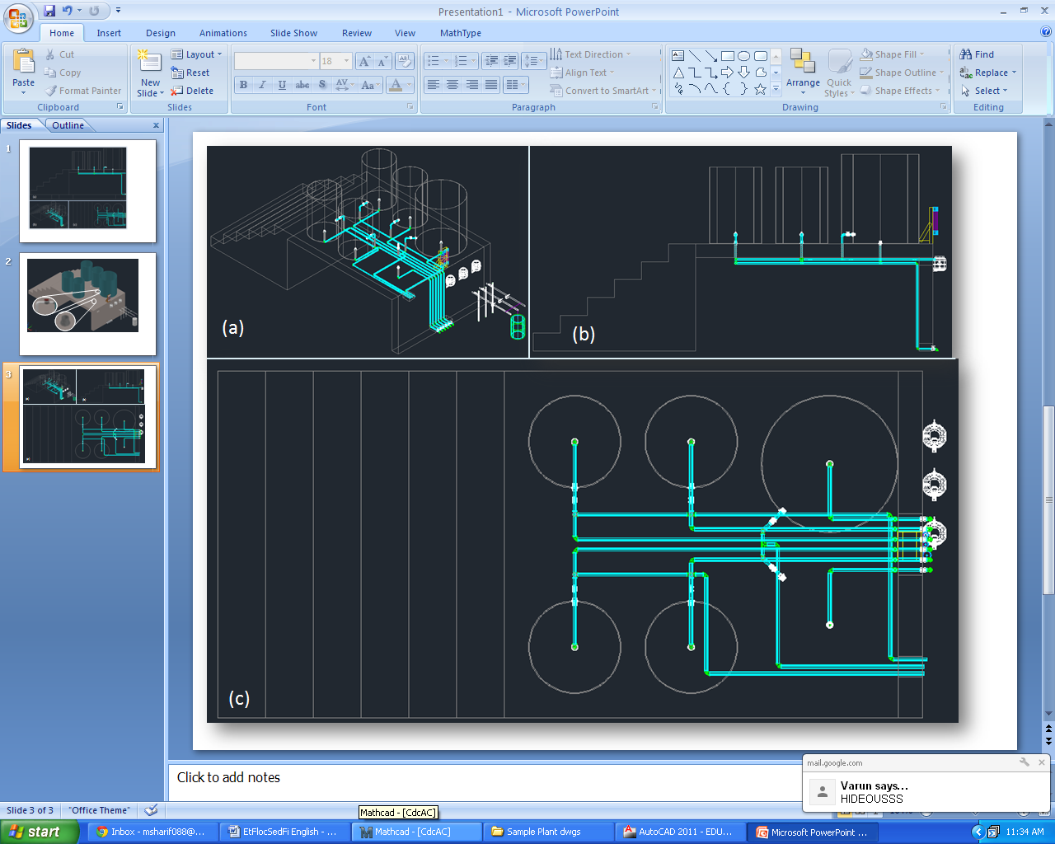

Figure . Southeast isometric (a), front (b), and top (c) views of the chemical stock tanks for an 18 L/s plant with a main plant coagulant tank left out for a clearer view of the piping.

Figure . 18 L/s plant with a main plant coagulant tank left out for a clearer view of the piping. The dosing plumbing (a) is connected to the stock tanks via bulkhead fitting and the flow is controlled using a ball valve. A male insert (b) is affixed to the bottom of the stock tanks, ultimately leading to ball valves (c) that sit at the edge of the main plant drain channel.

## Rapid Mix

Once it has been dosed with coagulant, the water passes through the rapid mix system. Rapid mix serves to uniformly distribute the coagulant through the raw water. In this plant, the rapid mix occurs as turbulent flow through a pipe with an inner diameter of ND.RMPipe. This pipe brings water from the point at which coagulant is dosed to the filters.

## Low Flow Stacked Rapid Sand Filtration: LFSRSF

|  |  |  |
| --- | --- | --- |
| Number of Filters | N.Fi | |
| Wall Thickness | T.FiWall | |
| Flow through single Filter | Q.Fi | |
| Bottom Elevation | Z.FiBottom | |
| *Sand* | | |
| Number of Filter Layers | N.FiLayer | |
| Height of Filter Layers | H.FiLayer | |
| Height of Bottommost Layer | H.FiBottomLayer | |
| Height of Sand | H.FiSand | |
| d60 | D.FiSand60 | |
| Porosity | Porosity.Sand | |
| *Trunk Lines* | | |
| Main Trunk Diameter | ND.FiTrunk | |
| Backwash Trunk Diameter | ND.FiBwTrunk | |
| *Branches* | | |
|  | Main Layers | Backwash Layer |
| Branch Diameter | ND.FiManBranch | ND.FiBwManBranch |
| Slot Spacing | B.FiManSlot | B.FiBwManSlot |
|  |  |  |

Las plantas de AguaClara cuentan con unsistema de filtración no convencional. Comúnmente, solamenteplantas de grandescaudalespuedenpermitirse la incorporación de unfiltro de arena. Los filtros de arena convencionalesusangrandescantidades de agualimpiapara el retrolavado, electricidad, y son de construcción y mantenimientocomplejo, incluyendovariasválvulas y piezasque se rompen con facilidad y son difíciles de reponer.

Porestasrazones, el equipo de AguaClara ha diseñadounfiltro con unasrestricciones de diseñoque no use electricidad, evite el uso de válvulas y piezascaras y de difícilobtención, que use pocaagua, quecada parte del filtro sea visible y accesiblepara el operador, y que sea de fácilmanejo.

Usando los principios de perdida de cabeza y aprovechandolasdiferencias de alturadelagua, el equipo de AguaClara creo un diseño de tresfiltros de arena en uno (FRAMCa). Este diseño reduce la cantidad de aguaque se necesita, y gracias a sutamañocompacto y sencillo, unaplanta de relativamentepocoflujopuedecontar con tresfiltros de arena.

Filtration begins once the settled water leaves the sedimentation tank. To ensure the filter functions optimally, the water must be sufficiently treated at the start of the process to a low turbidity. The filter must be washed regularly to liberate particulates trapped in the void space of the filter media. Once the water leaves the filter, it is sent to a distribution tank where chlorine is applied to destroy the last of the particulates.

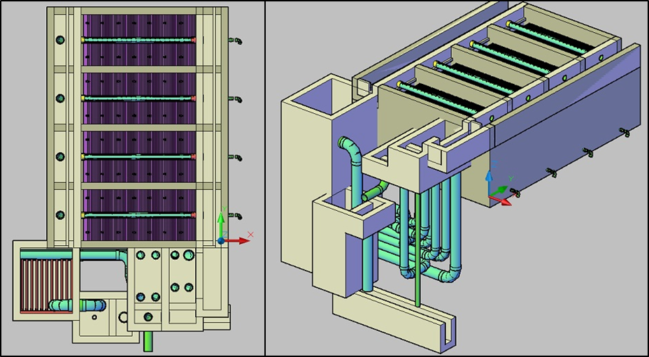

Figure 18.( Left) Top view of the sedimentation tank and a single filter below it. (Right) Isometric view of the filtration unit and sedimentation tank.

The SRSF has eight components:an entrance channel, an entrance box, a filter box, a distribution tank, caja de salida, caja de rebose, a backwash channel, a backwash box, and a siphon.

Figure 17 and **Error! Reference source not found.**show the layout of the filter. Water from the sedimentation tank enters the entrance channel then into the entrance box over a weir, flowing into the inlet manifold pipes. During filtration, all four pipes are utilized to distribute flow evenly to each of the six sand layers in the filter box and flow exits through the exit manifold into the exit box. Once in the exit box, the filtered water flows over a weir and is then piped to a distribution tank.

Figure 16**Error! Reference source not found.**more clearly shows the parts of the filter associated with backwash. For backwash operation, all water in the entrance channel will only flow through the bottom inlet manifold pipe. The dirty backwash water will then flow through the siphon into the backwash box. The backwash weir makes up one wall of the backwash box and controls the height of water throughout the filtration system. The dirty water flows over the weir from the backwash box into the backwash overflow box, then down a pipe to the drain channel.

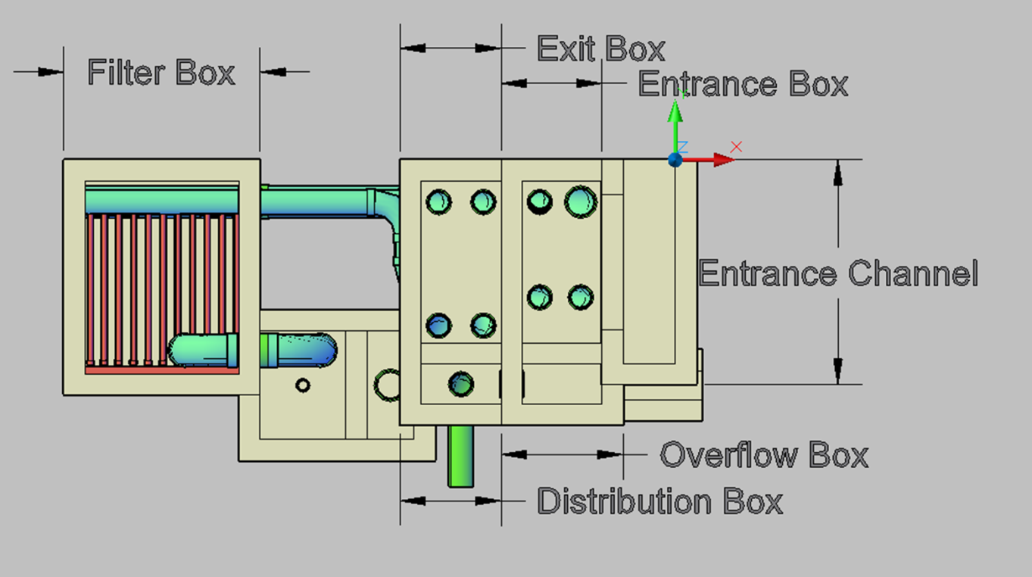

Figure 19. Top view of the filter labeled for filtration flow.

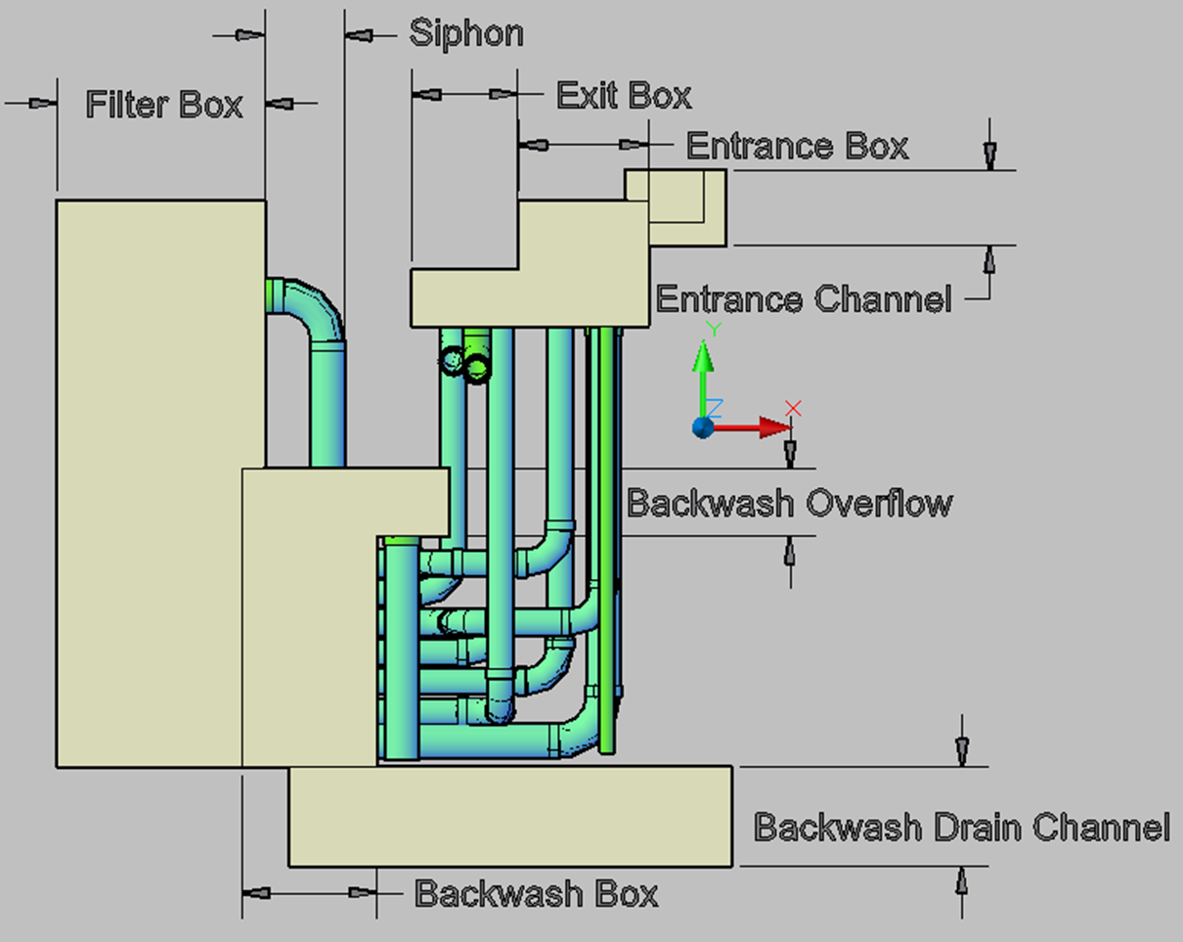

The siphon must be large enough to allow for draining all the water in the filter in a reasonable amount of time, set to be 3 minutes as well as have less than 10 cm of head loss at steady state.

# Materials List

Estaseccion describe parametrosutiles y estimaciones de los materials necesariospara la construccion de estaplanta. Las dimensiones y materials descritasaquiestandivididasacorde a la unidadoperacional de la planta a la quepertenecen.

### Entrance Tank

* El volumen de concretonecesarioparaconstruir el tanque de entradaesVol.EntranceTank.
* El suelodeltanque de entradatiene un area de A.EtFloor.

### SRSF

Manguera que trae el sulfato de aluminio de los tanques de almacenamiento de coagulante

Manguera dosificadora colgada de un tornillo

Contrapeso

Botella con válvulaflotadora

Balanza graduada

Tanque de entrada

Flotador

Reglilla

Agujeros del vertedero

Goteo de coagulante

(apagado)

Nivel constante

Agua en el tanque de entrada